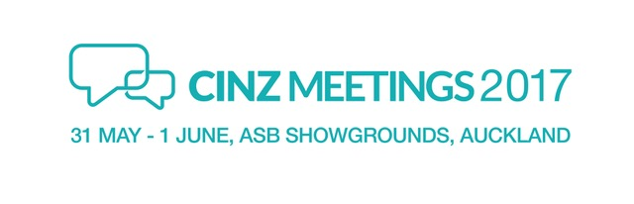

News release
16 January 2017

CINZ Meetings 2017 off to a strong start

Floor space is filling fast for CINZ Meetings 2017, New Zealand’s only national tradeshow for the conference and business tourism industry.

Organised by Conventions and Incentives New Zealand (CINZ) the Meetings event, now in its 21st year, is set for host city Auckland on 31 May and 1 June.

CINZ Chief Executive Sue Sullivan says exhibitors have been quick to secure their slots for New Zealand’s most important face-to-face business event of the year.

Meetings 2017 has a new look website, and several new initiatives to connect 600 qualified buyers and more than 20 leading industry media with 190 exhibitors from 18 regions around New Zealand.

Sue Sullivan says demand for hosted buyer places remains strong and CINZ has already secured key conference and event organisers to the show.

“Our partnership with Air New Zealand and Tourism New Zealand continues and their valued support will see the return of international buyers and media from North America, China, South East Asia and India,” she says.

“Australian hosted buyers and media will again join us with the support of Air New Zealand. We will make the most of their time here by offering 10 different regional familiarisation options, plus a day experience in Auckland before the show,” she says.

CINZ MEETINGS 2016 generated over $55million of signed business over its two days of pre-scheduled appointments.

“After great feedback last year, we have evolved the programme a step further by allowing day buyers to opt in to pre-scheduled appointments, giving them individual time with exhibitors where needed.

As well as set appointments, exhibitors also have valuable opportunities to connect with buyers in more informal settings across three days. Fully catered morning and afternoon teas, lunches and drinks are a hallmark of Meetings’ relaxed tradeshow environment, and the fun social programme includes daily networking events.

Meetings’ media programme is also expanding in 2017 and will includes press conferences, regional briefings and familiarisations, plus interview opportunities with leading industry players from around New Zealand.

The VIP programme for CEOs, government representatives and national association and tourism professionals includes industry updates and an exclusive walk around the floor.

CINZ Meetings 2017 exhibitor prospectus is out now and final applications for exhibitor bookings close on 17 March.

ENDS

CINZ Meetings 2017 key facts

- Conventions and Incentives New Zealand (CINZ) has been running CINZ Meetings annually since 1997.
- CINZ Meetings is New Zealand’s leading platform for connecting influential domestic, Australian and international buyers with key regions, meeting facilities, accommodation, off-site venues and activities.
- Auckland is the host city for CINZ Meetings 2017, at ASB Showgrounds.
- Air New Zealand is Principal Sponsor for CINZ Meetings 2017.
- Other major sponsors are ASB Showgrounds, Peek Exhibition and Centium Software.

For further information and images, please contact:

Anabel Darby
CINZ Meetings 2017 Media Manager
Tel: +64 21 668 090
Email: anabel@darby.pro

